IOT PRACTICAL
note: SOME IMPORTED SENSORS NEED TO ADD HEX FILE IN PROTUES BY EDIT PROPERTIES
Q1) To write a program to sense the available networks using Arduino
#include <ESP8266WiFi.h>

void setup() {
Serial.begin(115200);
WiFi.disconnect(); // disconnect previously connected access point
delay(200); // delay 200ms

Serial.println("***** WiFi Scan Started *****");
}

void loop() {

int n = WiFi.scanNetworks(); // WiFi.scanNetworks will return the number of networks found

Serial.println("Scan done");

if (n == 0)
Serial.println("No Network Found");
else
{
Serial.print(n);
Serial.println(" Networks found");
for (int i = 0; i < n; ++i)
{
// Print SSID, RSSI, MAC, Encryption for each network found
Serial.print(i + 1); //Sr. No
Serial.print(": ");
Serial.print(WiFi.SSID(i)); //SSID
Serial.print(" (");
Serial.print(WiFi.RSSI(i)); //Signal Strength
Serial.print(") MAC:");
Serial.print(WiFi.BSSIDstr(i));
Serial.println((WiFi.encryptionType(i) == ENC_TYPE_NONE)? " Unsecured" : " Secured" );
delay(10);
}
}
Serial.println("");

delay(6000); // delay 6sec
}
Ǫ2) Interfacing of Ultrasonic Sensor with Arduino
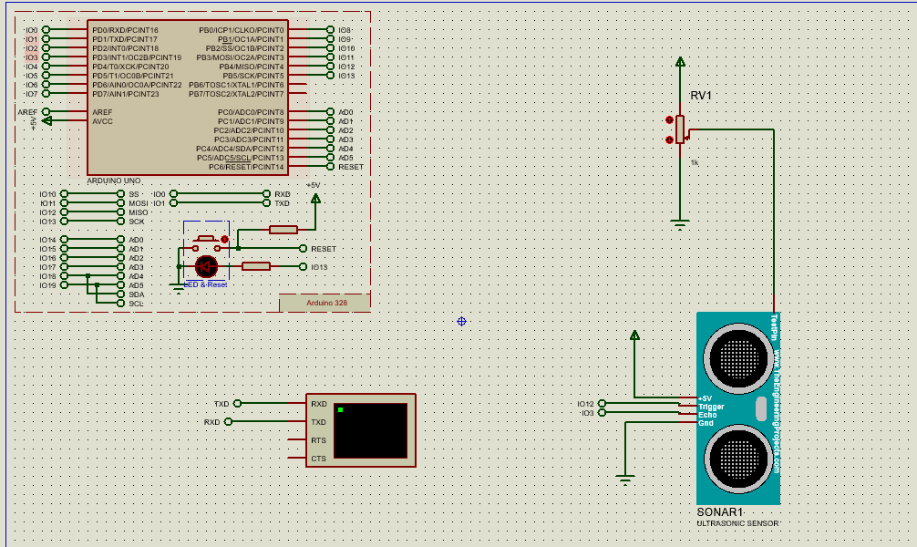
Program:
const int trigpin=12;
const int echopin=3;
long duration;
int distance;
void setup()
{
pinMode(trigpin,OUTPUT);
pinMode(echopin,INPUT);
Serial.begin(9600);
}
void loop()
{
digitalWrite(trigpin,LOW);
delayMicroseconds(2);
digitalWrite(trigpin,HIGH);
delayMicroseconds(10);
digitalWrite(trigpin,LOW);
duration=pulseIn(echopin,HIGH);
distance=duration*0.03412/2;
Serial.print("Distance");
Serial.print(distance);
Serial.println(" cm");
delay (500);
}
OUTPUT:
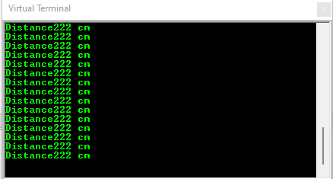

Ǫ3. Interfacing of Vibration Sensor with Arduino
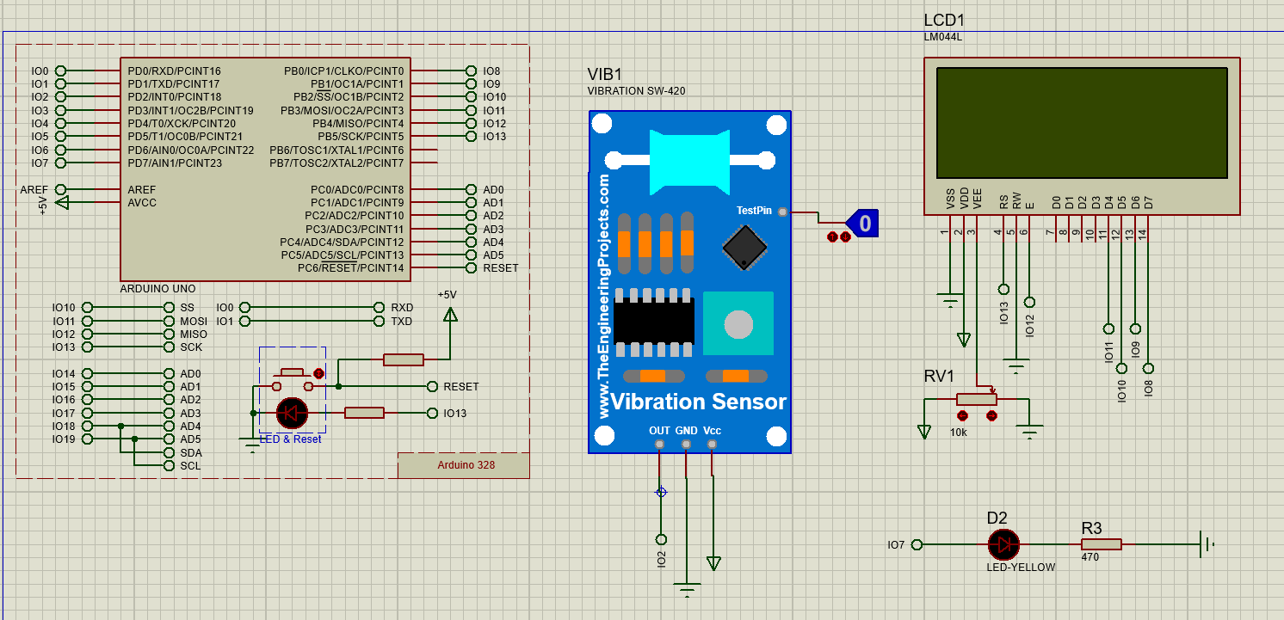
Program:

#include <LiquidCrystal.h>
LiquidCrystal lcd(13, 12, 11, 10, 9, 8);
const int SensorPin = 2;
const int LEDPin = 7;
void setup() {
pinMode(SensorPin, INPUT);
pinMode(LEDPin, OUTPUT);
lcd.begin(20, 4);
lcd.print("Hello");
lcd.setCursor(0,0);
lcd.print(" THE BRIGHT LIGHT ");
lcd.setCursor(0,1);
lcd.print(" VIBRATION SENSOR");
}
void loop() {
if(digitalRead(SensorPin) == HIGH){
digitalWrite(LEDPin,HIGH);
lcd.setCursor(0,3);
lcd.print(" Vibration Detected ");
delay(50);
lcd.setCursor(0,3);
lcd.print(" Vibration Detected. ");
delay(70);
lcd.setCursor(0,3);
lcd.print(" Vibration Detected.. ");
delay(70);
lcd.setCursor(0,3);
lcd.print(" Vibration Detected... ");
delay(70);
}
else{
digitalWrite(LEDPin,LOW);
lcd.setCursor(0,3); lcd.print(" No Vibration ");
}
}

OUTPUT:

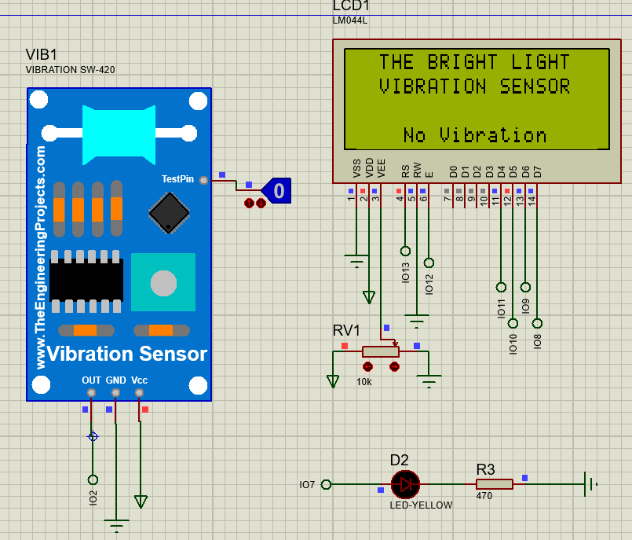
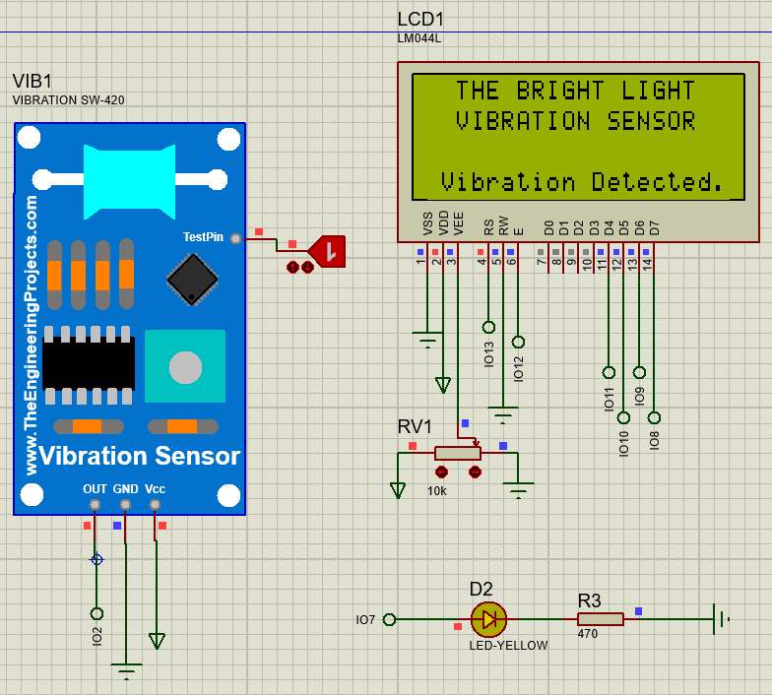

Q4. To write a program to sense a finger when it is placed on the board Arduino.

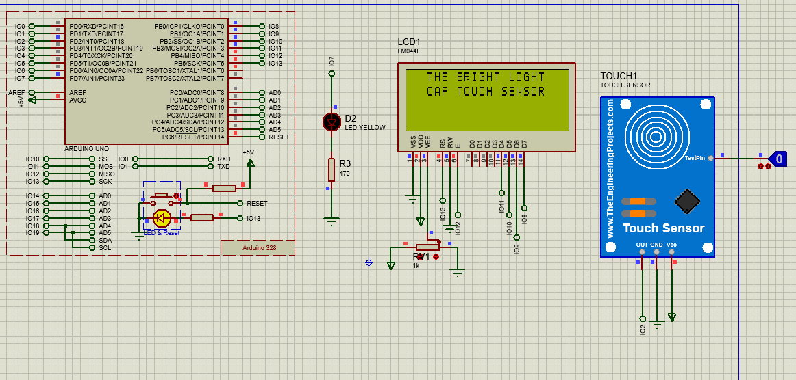

Program:

// include the library code:
#include <LiquidCrystal.h> //library for LCD

// initialize the library with the numbers of the interface pins
LiquidCrystal lcd(13, 12, 11, 10, 9, 8);

// defines pins numbers
const int SensorPin = 2;
const int LEDPin = 7;

void setup()
{
pinMode(SensorPin, INPUT); // Sets the Pin as an Input
pinMode(LEDPin, OUTPUT); // Sets the Pin as an OUTPUT

lcd.begin(20, 4); // set up the LCD's number of columns and rows:
lcd.setCursor(0,0); // set the cursor position:
lcd.print(" THE BRIGHT LIGHT ");
lcd.setCursor(0,1);
lcd.print(" CAP TOUCH SENSOR");
}
void loop()
{
int Val = analogRead(SensorPin); // Read the analog value form sensor
int Flex = map(Val,0,1019,0,90);
if(digitalRead(SensorPin) == HIGH)
{
lcd.setCursor(0,3);
lcd.print(" Touched ");
digitalWrite(LEDPin,HIGH);
}
else
{
lcd.setCursor(0,3);
lcd.print(" ");
digitalWrite(LEDPin,LOW);
}
}

Output:
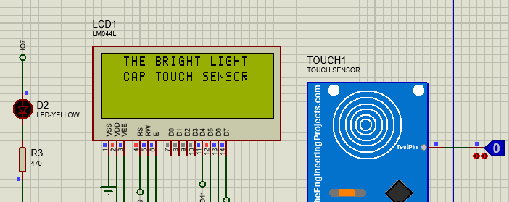

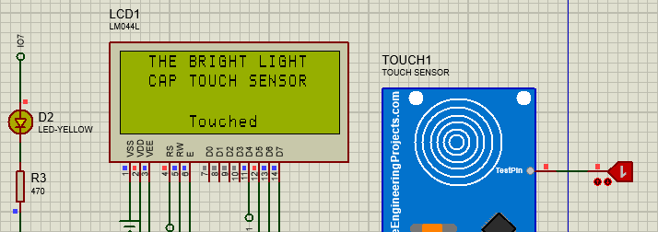

Q5. To write a program to connect with the available Wi-Fi using Arduino.
Program:
#include <ESP8266WiFi.h>

void setup() {
// put your setup code here, to run once:
Serial.begin(9600);
WiFi.begin("iot", "project1234");
while(WiFi.status() != WL_CONNECTED)
{
Serial.print("..");
delay(200);
}
Serial.println();
Serial.println("NodeMCU is Connected!");
Serial.println(WiFi.localIP());

}

void loop() {
// put your main code here, to run repeatedly:

}

Ǫ6. Interfacing of LM35 with Arduino
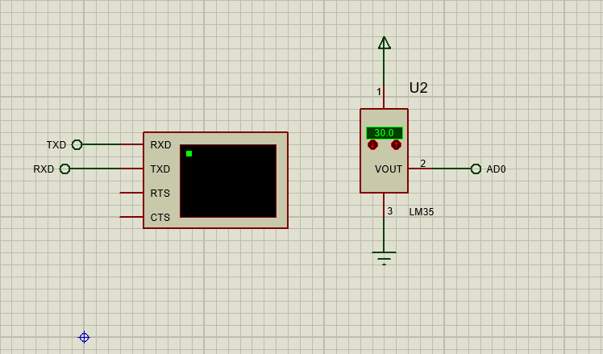
Program
int val;
int tempPin = A0;
void setup(){
Serial.begin(9600);
}
void loop()
{
val = analogRead(tempPin);
float mv = (val/1024.0) * 5000;
float cel = mv / 10;
float farh = (cel * 9) / 5 + 32;
Serial.print("Temperature = ");
Serial.print(cel);
Serial.print(" *C,");
Serial.print(farh);
Serial.println(" *F");
delay(1000);
}

OUTPUT:
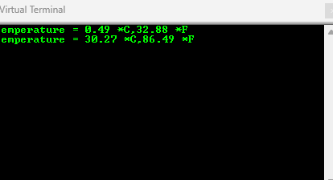

Ǫ7. Interfacing of LDR with Arduino
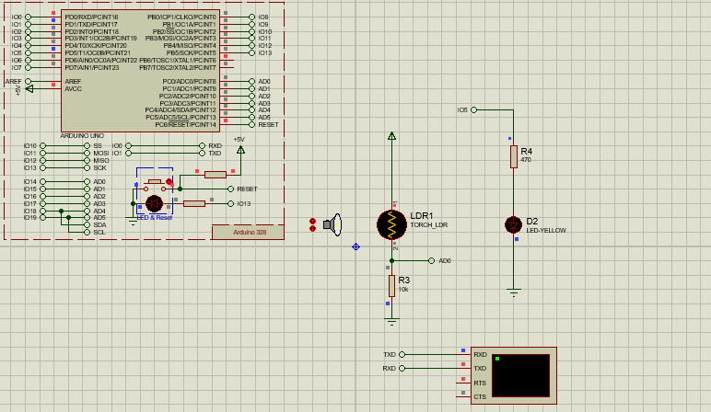
Program:
const int ledPin = 5;
const int ldrPin = A0;
void setup(){
Serial.begin(9600);
pinMode(ledPin,OUTPUT);
pinMode(ldrPin,INPUT);
}
void loop(){
int ldrStatus = analogRead(ldrPin);
if(ldrStatus <= 200){
digitalWrite(ledPin,HIGH);
Serial.print("Darkness, then LED ON: ");
Serial.println(ldrStatus);
}
else{
digitalWrite(ledPin,LOW);
Serial.print("Darkness, then LED off: ");
Serial.println(ldrStatus);
}
OUTPUT:

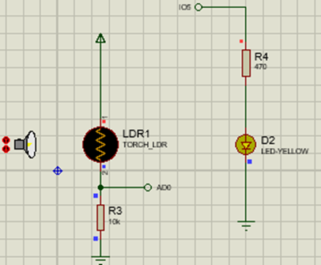 | 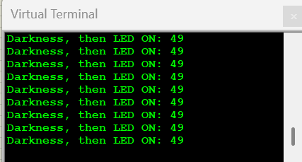
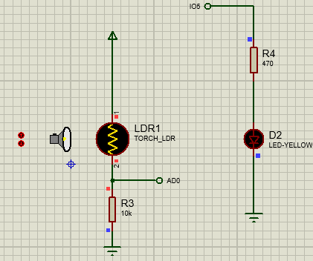 | 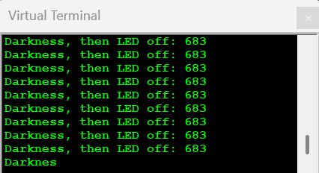

Q9. Run some python programs on Pi like:
a) Read your name and print Hello message with name

Program:
name = input("Enter your name: ")

# a hello message
print("Hello", name, "welcome to Python programming!")

OUTPUT:
Enter your name: JS
Hello JS welcome to Python programming!

b) Word and character count of a given string.

Program:
text = input("Enter a string: ")

# counting words and characters
word_count = len(text.split())
char_count = len(text)

print("Number of words:", word_count)
print("Number of characters:", char_count)

OUTPUT:
Enter a string: Python is fun
Number of words: 3
Number of characters: 13

c) Read two numbers and print their sum, difference, product and
Program:

A = float(input(“Enter first number: “))
B = float(input(“Enter second number: “))
Print(“Sum:”, a + b)
Print(“Difference:”, a – b)
Print(“Product:”, a * b)
If b != 0:
Print(“Division:”, a / b)
Else:
Print(“Division: Infinity (division by zero)”)

OUTPUT:
Enter first number: 8
Enter second number: 2
Sum: 10.0
Difference: 6.0
Product: 16.0
Division: 4.0

d) Area of a given shape (rectangle, triangle and circle)
Program:
shape = input(“Enter shape(rectangle,triangle,circle):”).lower()
If shape == “rectangle”:
Length = float(input(“Enter length: “))
Breadth = float(input(“Enter breadth: “))
Area = length * breadth
Print(“Area:”, area)

Elif shape == “triangle”:
Base = float(input(“Enter base: “))
Height = float(input(“Enter height: “))
Area = 0.5 * base * height
Print(“Area:”, area)

Elif shape == “circle”:
Radius = float(input(“Enter radius: “))
Area = 3.14 * radius * radius
Print(“Area:”, area)

Else:
Print(“Unknown shape. Please enter rectangle, triangle, or circle.”)

OUTPUT
Enter shape(rectangle,triangle,circle): triangle
Enter base: 6
Enter height: 3
Area: 9.0

Q10 ) Run some python programs on Pi like:

a) Print a name 'n' times, where name and n are read from standard input, using for and while loops.
Program:
name = input("Enter your name: ")
n = int(input("Enter how many times to print your name: "))

# Using for loop
print("\nUsing for loop:")
for i in range(n):
print(name)

# Using while loop
print("\nUsing while loop:")
i = 0
while i < n:
print(name)
i += 1
OUTPUT:
Enter your name: JS
Enter how many times to print your name: 3

Using for loop:
JS
JS
JS

Using while loop:
JS
JS
JS
b) Handle Divided by Zero Exception.
Program:

a = int(input("Enter numerator: "))
b = int(input("Enter denominator: "))

# Handle divide by zero exception
try:
result = a / b
print("Result =", result)
except ZeroDivisionError:
print("Error: Division by zero is not allowed!")
OUTPUT:
Enter numerator: 10
Enter denominator: 2
Result = 5.0
Enter numerator: 10
Enter denominator: 0
Error: Division by zero is not allowed!
c) Print current time for 10 times with an interval of 10 seconds.
Program:
import time
from datetime import datetime

# Loop 10 times
for i in range(10):
# Get current time
current_time = datetime.now().strftime("%H:%M:%S")
print(f"{i+1}. Current Time:", current_time)

# Wait for 10 seconds before next print (except last time)
if i < 9:
time.sleep(10)
OUTPUT:

1. Current Time: 12:45:10
2. Current Time: 12:45:20
3. Current Time: 12:45:30
...
10. Current Time: 12:46:40
d) Read a fileline byline and print the word count of each line
Program:
filename = input("Enter the file name: ")

try:
# Open the file in read mode
with open(filename, 'r') as file:
line_number = 1
for line in file:
# Remove extra spaces and newlines
words = line.split()
word_count = len(words)
print(f"Line {line_number}: {word_count} words")
line_number += 1
except FileNotFoundError:
print("Error: File not found. Please check the file name.")
File: sample.txt
Python is fun
I love programming
ChatGPT helps in learning
OUTPUT:

Line 1: 3 words
Line 2: 3 words
Line 3: 4 words

Q11 Run some python programs on Pi like

a) Light an LED through Python program

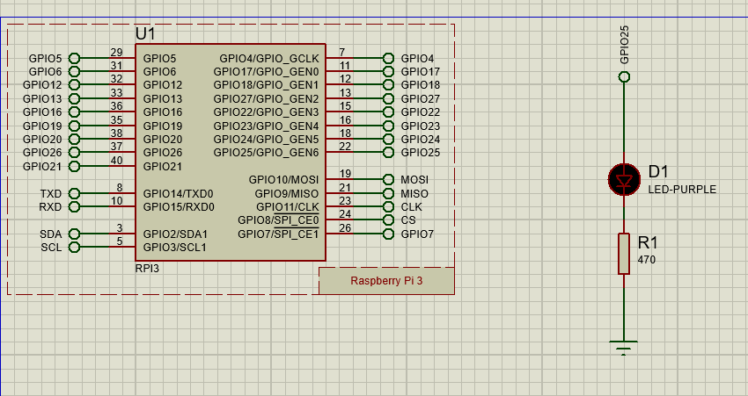

Program:
import RPi.GPIO as GPIO
import time

GPIO.setmode(GPIO.BOARD)
LED1 = 22
GPIO.setup(LED1,GPIO.OUT)
while True:
GPIO.output(LED1,True)
time.sleep(2)
GPIO.output(LED1,False)
time.sleep(2)

OUTPUT:
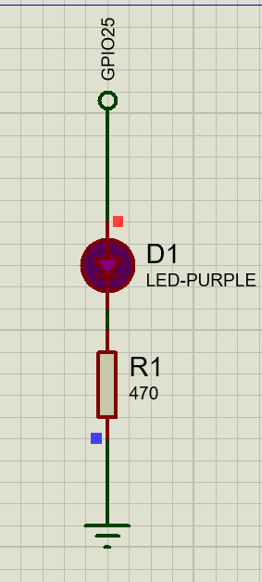

b) Get input from two switches and switch on corresponding LEDs

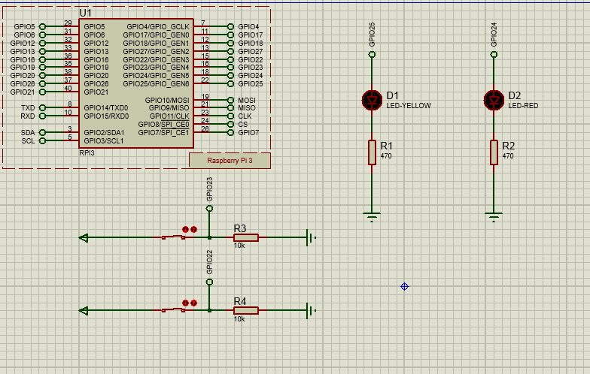

Program:

import RPi.GPIO as GPIO
import time

GPIO.setmode(GPIO.BOARD)

# Define pins
LED1 = 22
LED2 = 18
SW1 = 15
SW2 = 16

# Setup
GPIO.setup(LED1, GPIO.OUT)
GPIO.setup(LED2, GPIO.OUT)
GPIO.setup(SW1, GPIO.IN, pull_up_down=GPIO.PUD_DOWN)
GPIO.setup(SW2, GPIO.IN, pull_up_down=GPIO.PUD_DOWN)

print("Press switches to turn ON corresponding LEDs...")

while True:
# Switch 1 controls LED 1
if GPIO.input(SW1) == GPIO.HIGH:
GPIO.output(LED1, True)
else:
GPIO.output(LED1, False)

# Switch 2 controls LED 2
if GPIO.input(SW2) == GPIO.HIGH:
GPIO.output(LED2, True)
else:
GPIO.output(LED2, False)

time.sleep(0.1) # small delay for stability

OUTPUT:

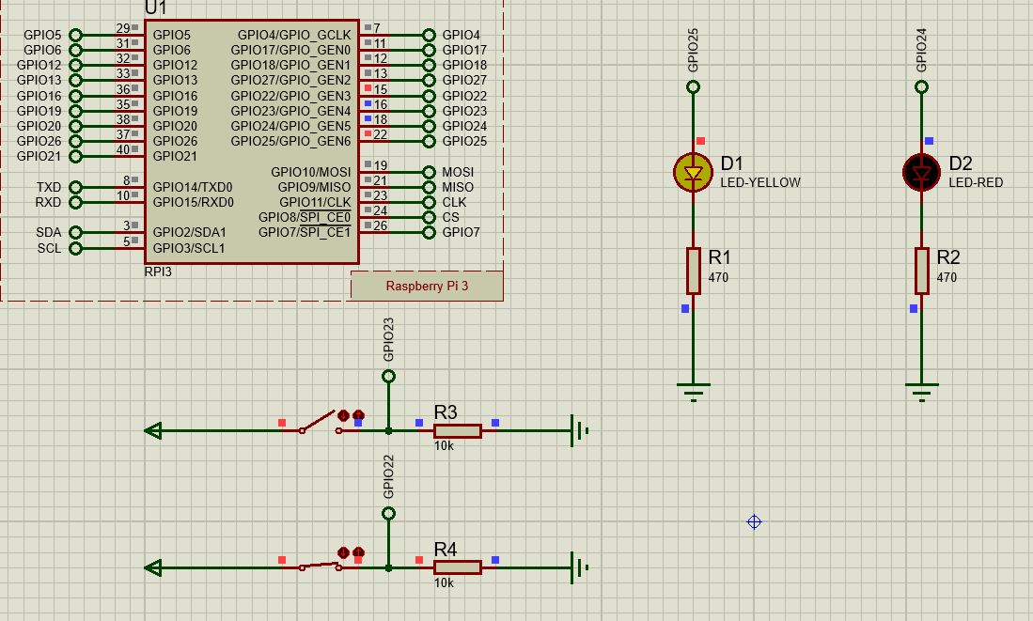
c) Flash an LED at a given on time and off time cycle, where the two times are taken from a file

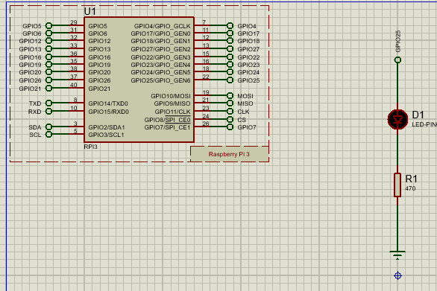

Program:

import RPi.GPIO as GPIO
import time

GPIO.setmode(GPIO.BOARD)
LED = 22
GPIO.setup(LED, GPIO.OUT)

# Read on and off times from file
# 1.5 ON time, 0.5 OFF time
with open("timing.txt", "r") as f:
on_time, off_time = map(float, f.read().split())

# Blink LED forever
while True:
GPIO.output(LED, True)
time.sleep(on_time)
GPIO.output(LED, False)
time.sleep(off_time)

File: timing.txt
1.5 0.5

OUTPUT:

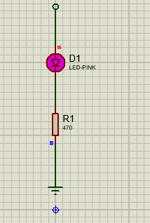

Extra :
